Diamond, Nikki

From: Paul Field [pwf@centor.co.uk]
Sent: 22 January 2014 11 :20
To: Diamond, Nikki
Subject: RE: 2013/00206 RE: Breaks into units 3/4 Horizon 1 Est

This seems to have been outstanding for a long time - all, OK? If you can let me have a brief update, I would be grateful.
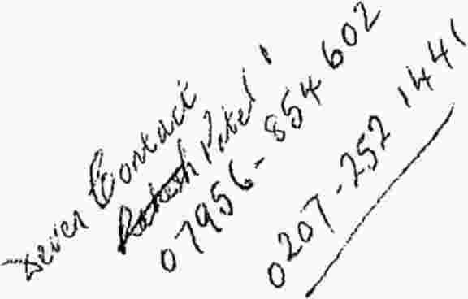Paul Field
Claims and Support Director

CENTOR INSURANCE & RISK MANAGEMENT LTD
17 Dominion Street
London EC2M 2EF
UK Broker Awards 2012 -Winner - Claims Service of the Year
UK Broker Awards 2013 -Winner - Commercial Lines Broker of the Year
Authorised and regulated by the Financial Conduct Authority
Voice : +44 020 7330 8702
Fax : +44 020 7256 9455
Email : pwf@centor.co.uk
Web: www.centor.co.uk
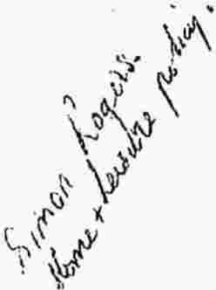CENTOR INSURANCE & RISK MANAGEMENT LIMITED is a company registered in England. Company Number 1151611.
Registered Office: 17 Dominion Street, London, EC2M 2EF. Authorised and regulated by the Financial Conduct Authority.

From: Diamond, Nikki [mailto:Nikki.Diamond@cl-uk.com]
Sent: 18 November 2013 10:44
To: Paul Field
Subject: RE: 2013/00206 RE: Breaks into units 3/4 Horizon 1Est

Hi Paul,
I have reviewed the quotations and I have asked Mr. Patel for some further clarification.
In particular, I will require the quotations to be itemized so I can see the costs for each area of work.
I have also asked for some details about the previous alarm system and the proposed replacement, and for clarification of the electrical rewiring works.
As soon as I have the above, I should be able to consider the quotations again and agree settlement. Kind Regards,
Nikki Diamond BSc (Hons) Cert CILA

1

